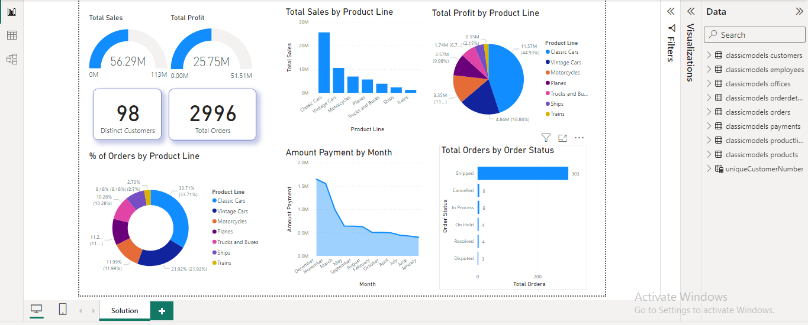**SOUTION EXPLAINATION**

The data provided to me consisted of details from the MySQL sample database schema, which encompasses eight tables:

**DATA:**

**Customers**: This table stores customer data.

**Products**: It contains a list of scale model cars.

**ProductLines**: This table stores a list of product line categories.

**Orders**: It stores sales orders placed by customers.

**OrderDetails**: This table contains sales order line items for each sales order.

**Payments**: It stores payments made by customers based on their accounts.

**Employees**: This table stores all employee information, including the organizational structure, such as reporting relationships.

**Offices**: This table stores sales office data.

**SQL DATABASE:**

During this step, I initiated the creation of a database named "classicmodels" using the SQL command "CREATE DATABASE classicmodels." Subsequently, I created the eight specified tables and populated each table with the provided data.

**CONNECTIVITY OF POWERBI AND SQL:**

In this phase, I established a connection between Power BI and the MySQL database. I utilized the "Get Data" option in Power BI, selecting the MySQL database and providing the necessary connection details, including the database server, port, database name, and MySQL password. As a result, all tables appeared in the right panel of the Power BI interface, with data automatically populated.

**POWERBI:**

**A) DATA ANALYSIS:**

Within the Power Query tab, accessed through the "Transform Data" option in the top panel, I comprehensively examined the columns of all tables. I performed various data manipulations, such as creating new columns through calculations (e.g., extracting month and year from the date column), adjusting data types for clarity, removing extraneous columns, and reordering columns to enhance data understanding.

**B) DATA VISUALIZATION:**

Moving to the report view, I initiated the construction of Key Performance Indicators (KPIs) for data insights using columns from the tables displayed in the right panel. I optimized views for improved visualization, applied filters, and implemented basic aggregation. Additionally, I utilized tabular views to inspect data columns, created additional tables to extract unique values from a column, and established relationships among columns in the model view of Power BI. This approach ensured that the entire dashboard was interactive and capable of showcasing meaningful data insights.

**DASHBOARD**

The dashboard comprises various visual elements designed to provide a comprehensive overview of key metrics and trends. These elements include:

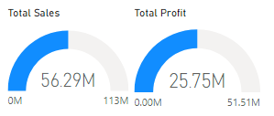**Gauges:**

Total Sales: A gauge depicting the overall sum of sales.

Total Profit: A gauge representing the cumulative profit.

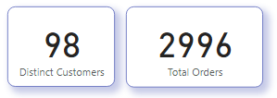**Cards:**

Distinct Customers: A card displaying the count of unique

customers.

Total Orders: A card presenting the total number of orders.

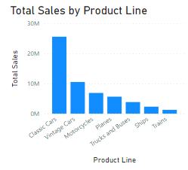

**Stacked Column Chart:**

Total Sales by Product Line: A chart illustrating the

distribution of total sales across different product lines

through stacked columns.

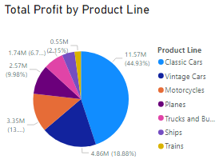

**Pie Chart:**

Total Profit by Product Line: A chart portraying the

proportion of total profit attributed to each product line

using a pie chart.

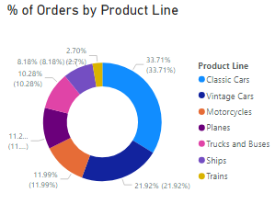

**Donut Chart:**

Percentage of Orders by Product Line: A chart presenting

the distribution of orders across product lines, represented

as a donut chart to showcase the percentage composition.

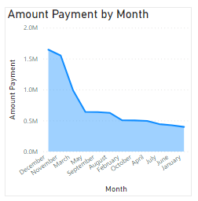

**Area Chart:**

Amount Payment by Month: An area chart displaying the

trend of payment amounts over months, providing

insights into payment patterns and fluctuations.

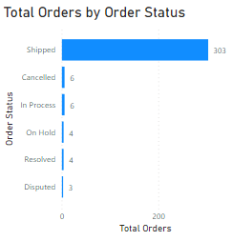

**Stacked Bar Chart:**

Total Orders by Order Status: A chart depicting the total count

of orders categorized by their status, presented through stacked

bars. This offers a visual representation of the distribution of

orders based on their current status.